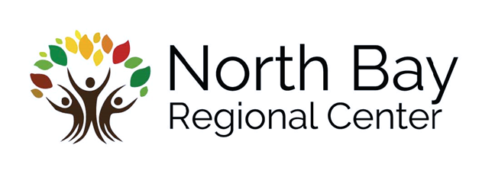

**When: Tuesday, May 16, 2017**

**9:30 – 5:00 p.m.; registration 9:00 a.m.**

**Where: NBRC 610 Airpark Road, Napa**

**CEU’s: $10 fee for 7 continuing education units**

**RSVP by 5/2**

**Send completed NPO registration form to Erika Dominguez**

**erikad@nbrc.net (707) 256-1287**

Topics Include:

◻ Overview of the Lanterman Act and Title 17 regulations

◻ Steps to becoming a vendor

◻ Creating a good program design

◻ Client’s Rights

◻ Regional Center monitoring responsibilities and process

◻ Maintaining proper records

◻ Special Incident Reporting

**Required for:**

**-Potential NBRC Residential Providers**

**-Adult Family Home Agency Employees**

**-Current NBRC Administrators who want to open a home, and who have not completed New**

**Provider Orientation within the past two years.**

**New Provider Orientation**