Regional Self Advocacy Meeting

Tuesday, September 29, 2015
10:30 am – 12:30 pm

Becoming Independent
1425 Corporate Center Parkway, Santa Rosa CA

Featured presenter – Ari Ne’eman

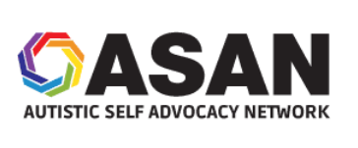
Ari Ne’eman is the President and co-founder of the Autistic Self Advocacy Network. In 2009, President Obama nominated Ari to the National Council on Disability, a federal agency charged with advising Congress and the President on disability policy issues. He was confirmed by the Senate in July 2010 and currently chairs the Council’s Entitlements Committee.

Ari will talk about how he became involved with self advocacy, the future of services for people who have developmental disabilities, and how you can get more involved in self advocacy. Don’t miss this opportunity to hear from a national self advocacy leader!

Please feel free to bring your own lunch. We will provide light refreshments. There is limited space available. Please RSVP by Sept 22nd to:

Annie Breuer, Disability Rights CA/Office of Clients Rights Advocacy,
707-224-2798, annie.breuer@disabilityrightsca.org

Cindy Ruder, State Council on Developmental Disabilities North Bay Office,
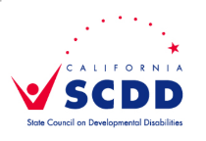
707-953-8403, cindy.ruder@scdd.ca.gov

Thank you to Becoming Independent for
use of their meeting space!

