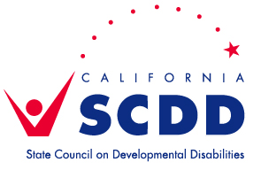

**North Bay Regional Center**

**Application -- Self-Determination Advisory Committee!**

Please provide the following information and return to Robin Tigh at the State Council on Developmental Disabilities, North Bay Office – 236 Georgia Street, Suite 201, Vallejo, CA 94590. Robin can be reached at 707-648-4073 or [robin.tigh@scdd.ca.gov](mailto:robin.tigh@scdd.ca.gov).

**NAME:______________________________________________________**

**ADDRESS*:__________________________________________________**

**PHONE NUMBER:_____________________________________________**

**E-MAIL ADDRESS:____________________________________________**

**ETHNICITY (OPTIONAL)*:_______________________________________**

**PLEASE INDICATE:**

* + **INDIVIDUAL WITH DEVELOPMENTAL DISABILITY**
* **FAMILY MEMBER**
* **OTHER (PLEASE EXPLAIN) ____________________________**

**Please provide a brief statement explaining your interest in this committee (include any relevant skills or experience):**

**Accommodations can be provided upon request. All applications must be received by June 19, 2015.**

**\*State law requires this committee to “reflect the multicultural diversity and geographic profile” of the NBRC region.**